Microservice Architecture Design Document
University ERP · Advanced Software Engineering · UCSC

1. Executive Summary
This document describes the microservice architecture designed for the University ERP system. The system decomposes a hypothetical monolithic academic platform into eight independently deployable services, each owning its own MongoDB database. Services communicate via synchronous REST (HTTP/JSON using axios) for real-time queries and asynchronous Kafka events for decoupled state propagation. External clients reach services through an NGINX reverse proxy that performs path-based routing. All services are implemented in Node.js with Express and validated with JWT tokens issued by the Auth Service.

2. System Context
The University ERP system supports three types of users: students (web browser, mobile app), administrators (admin portal), and automated internal processes. The system manages the full academic lifecycle: student registration, course enrolment, examination scheduling, result recording, transcript generation, and administrative reporting.
The previous architecture was a monolith. This redesign extracts each business capability into a separate service to achieve independent deployability, fault isolation, and horizontal scalability per domain.

3. Architectural Style — Microservices
The system adopts a microservice architectural style. The key principles applied are:
- Single Responsibility: each service is responsible for exactly one business domain.
- Database per Service: no service accesses another service's database directly.
- API-first: all cross-service communication goes through defined HTTP or event interfaces.
- Loose Coupling: services are unaware of each other's internal implementation.
- High Cohesion: all logic related to a domain lives inside one service.
- Design for Failure: services handle downstream unavailability gracefully.

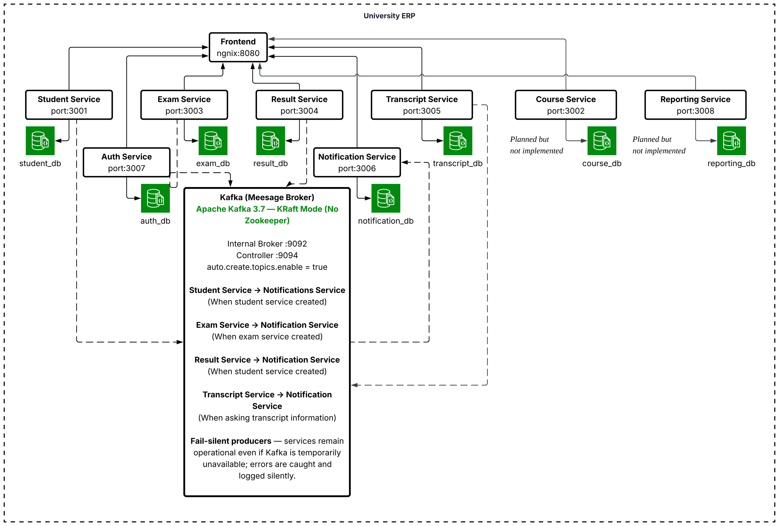

4. Service Catalogue
All eight services are described below. See the Service Identification Table for the full Service Identification Table.

4.1 Auth Service
Port | 3007
Database | auth_db
Description | Issues and validates JSON Web Tokens. All other services delegate authentication to their own JWT middleware using the shared JWT_SECRET — no service calls Auth Service at runtime. Auth Service is responsible for user login, token refresh, and bcrypt password management.

Key endpoints:
- POST /api/auth/register
- POST /api/auth/login
- POST /api/auth/refresh

4.2 Student Service
Port | 3001
Database | students_db
Description | Manages student profiles and enrolment records. The authoritative source for student identity across the system. Publishes student.created to Kafka when a new student registers.
Key endpoints:
- POST /api/students
- GET /api/students/:id
- GET /api/students

4.3 Course Service
Port | 3002
Database | courses_db
Description | Manages course definitions and modules. Provides course metadata consumed by the Exam and Transcript services via REST.
Key endpoints:
- POST /api/courses
- GET /api/courses
- GET /api/courses/:id

4.4 Exam Service
Port | 3003
Database | exams_db
Description | Creates exams and manages student exam entries. Before creating an entry, it verifies the student exists by calling GET /api/students/:id on the Student Service (synchronous REST). Publishes exam.registered to Kafka on successful enrolment.

Key endpoints:
- POST /api/exams
- GET /api/exams
- POST /api/exams/:id/entries
- GET /api/exams/:id/entries

4.5 Result Service
Port | 3004
Database | results_db
Description | Records exam results and grades. Publishes result.published to Kafka when a result is finalised, triggering downstream Notification, Reporting, and Transcript services.
Key endpoints:
- POST /api/results
- GET /api/results/:studentId
- GET /api/results/exam/:examId

4.6 Transcript Service
Port | 3005
Database | transcripts_db
Description | Generates PDF transcripts using pdfkit. Consumes result.published Kafka events to update its local snapshot of student grades. Fetches full result data from Result Service via REST when generating a transcript on demand.

Key endpoints:
- POST /api/transcripts/:studentId/generate
- GET /api/transcripts/:studentId

4.7 Notification Service
Port | 3006
Database | notif_db
Description | Kafka consumer that sends email or SMS notifications on three events: student.created, exam.registered, and result.published. Logs all sent notifications to notif_db for audit.
Key endpoints:
- GET /api/notifications/:studentId (audit log)

4.8 Reporting Service
Port | 3008
Database | reports_db
Description | Kafka consumer that aggregates metrics for the admin portal. Consumes result.published events to build snapshots of pass rates, grade distributions, and enrolment counts. Exposes REST endpoints for the admin dashboard.
Key endpoints:
- GET /api/reports/summary
- GET /api/reports/exam/:examId

5. Technology Decisions
Technology | Used By | Rationale
Node.js 20 (LTS) + Express.js | All Services | A single language across all services eliminates context-switching. Express is minimal and well-understood, with a large ecosystem. Node's non-blocking I/O suits the service pattern of handling many concurrent HTTP or Kafka messages.
MongoDB + Mongoose ODM | All Services (one DB each) | MongoDB's document model suits the varied schemas of university data (student profiles, exam entries, PDF metadata). Mongoose provides schema validation at the application layer while retaining flexibility. See Section 6 (Database Strategy) for the database strategy justification.
NGINX Reverse Proxy | Edge layer | Replaces a vendor API Gateway (Kong, AWS API Gateway). NGINX is free, lightweight, and performs path-based routing with no business logic. It reduces external attack surface by exposing only one host:port to clients.
JSON Web Tokens (jsonwebtoken + bcrypt) | All Services | Stateless authentication — no shared session store required. Each service validates the JWT independently using a shared JWT_SECRET, avoiding a runtime dependency on Auth Service for every request.
axios | Exam Service, Transcript Service | Promise-based HTTP client for synchronous cross-service REST calls. Used only where an immediate response is required (student verification, grade fetch).
Kafka + kafkajs | Exam, Result, Student, Notification, Transcript, Reporting | kafkajs is a pure Node.js Kafka client. Async events decouple producers from consumers, enabling independent scaling and zero-downtime consumer additions.
Docker + docker-compose | Infrastructure | Each service has a Dockerfile using node:20-alpine for minimal image size. docker-compose wires services, databases, and networking with one command, matching the architecture's service isolation in local development.

6. Database Strategy — Database-per-Service
Note: This section fulfils Deliverable Database Strategy, embedded here as permitted by the assignment brief to avoid duplication.

6.1 Decision: Database-per-Service
Each of the eight services owns exactly one MongoDB database, hosted on a shared MongoDB cluster (Atlas in production; Docker in development). No service is permitted to issue queries against another service's database — all cross-service data access must go through the owning service's API.

6.2 Why Not a Shared Database?
A single shared database was considered and rejected for the following reasons:
- Schema coupling: changes to a table/collection used by multiple services require coordinated deployments across those services, negating independent deployability.
- Contention and scaling: a single database becomes a bottleneck; it cannot be scaled independently per service load.
- Failure isolation: a misconfigured query in one service (e.g., a missing index on a large collection) can degrade database performance for all services.
- Ownership ambiguity: with a shared schema, it is unclear which service is responsible for data migrations or schema evolution.

6.3 Database Assignments
Service | Database | Key Collections
Auth Service | auth_db | users, tokens
Student Service | students_db | students, enrolments
Course Service | courses_db | courses, modules
Exam Service | exams_db | exams, entries
Result Service | results_db | results, grades
Transcript Service | transcripts_db | transcripts (PDF metadata)
Notification Service | notif_db | notifications (audit log)
Reporting Service | reports_db | snapshots, metrics

6.4 MongoDB Justification
MongoDB was selected over PostgreSQL (which appeared in early architecture drafts) for the following reasons:
- Schema flexibility: different services have vastly different data shapes. MongoDB's document model avoids the overhead of schema migrations during iterative development.
- Mongoose ODM: provides schema validation, middleware hooks (pre-save, post-save), and a familiar query API in Node.js, giving the benefits of structure without rigid SQL schemas.
- Single cluster, isolated databases: a MongoDB cluster natively supports multiple databases, enabling the database-per-service pattern without provisioning separate database servers.
- Consistency with the team's existing stack: all services are Node.js; MongoDB is the most natural fit in the MERN/MEAN ecosystem.

7. Inter-Service Communication

7.1 Synchronous REST (HTTP/JSON)
Used when an immediate, consistent response is required before proceeding. The caller blocks until the response is received. axios is used as the HTTP client.
Caller | Called | Endpoint | When
Exam Service | Student Service | GET /api/students/:id | Before creating an exam entry — verifies student exists
Transcript Service | Result Service | GET /api/results/:studentId | When generating a PDF transcript on demand

7.2 Asynchronous Kafka Events
Used for state propagation that does not require an immediate response. The producer emits an event and continues; consumers process it independently. This achieves loose coupling and allows the system to remain operational if a consumer is temporarily down (Kafka retains the event until the consumer catches up).

Event | Producer | Consumers | Trigger
student.created | Student Service | Notification Service | New student registered
exam.registered | Exam Service | Notification Service | Student enrolled in exam
result.published | Result Service | Notification Svc, Reporting Svc, Transcript Svc | Exam result finalised

8. NGINX Reverse Proxy Routing
NGINX acts as the sole external entry point. It routes requests by URL path prefix to the appropriate internal service. It does not perform authentication, rate limiting, or transformation — those are handled inside each service.
Path Prefix | Upstream Service | Port
/api/auth | Auth Service | 3007
/api/students | Student Service | 3001
/api/courses | Course Service | 3002
/api/exams | Exam Service | 3003
/api/results | Result Service | 3004
/api/transcripts | Transcript Service | 3005
/api/notifications | Notification Service | 3006
/api/reports | Reporting Service | 3008

9. Authentication Strategy
JWT (JSON Web Tokens) are used for stateless authentication. The Auth Service issues a signed JWT on login. The client includes the token in the Authorization: Bearer <token> header on every subsequent request. Each service independently validates the token using the shared JWT_SECRET environment variable — no runtime call to Auth Service is needed per request. This eliminates Auth Service as a single point of failure for authenticated requests and avoids adding latency to every API call.
Tokens expire after a configurable period (default: 24 hours). bcrypt is used for password hashing in the Auth Service with a work factor of 12.

10. Deployment Overview
All services are containerised using Docker with node:20-alpine base images. docker-compose.yml defines the full service topology for local development:
- student-service — port 3001, connects to mongo-students:27017/students_db
- exam-service — port 3003, connects to mongo-exams:27017/exams_db
- mongo-students — MongoDB 7, isolated volume (students-data)
- mongo-exams — MongoDB 7, isolated volume (exams-data)
- All services share erp-network (Docker bridge) for inter-service DNS resolution
- JWT_SECRET injected via .env file at runtime (not hardcoded)
Note: The prototype (Prototype) implements Student Service and Exam Service only. The remaining six services are designed in this document but noted as "designed, not implemented" in the prototype submission.

11. Assumptions and Constraints
- The prototype is scoped to two services (Student, Exam) as per the assignment brief for solo work.
- Kafka is included in the design but not wired in the prototype — events are noted in code comments.
- JWT_SECRET is shared across all services via environment variable; in production this would be managed by a secrets vault.
- MongoDB Atlas is the intended production host; Docker Compose MongoDB containers are for development only.
- NGINX configuration for the full eight services is defined in design but only Student and Exam paths are active in the prototype.
- No rate limiting or request throttling is implemented in the prototype scope.

References: Service Identification Table, Bounded Context Diagram, API Endpoint Design, Service Communication Diagram, Benefits & Risks.

